Practical - 1

Practical Title: Project Initiation, Requirement Analysis, Sitemap, Wireframe, and GitHub Setup
Problem Definition: Initiate the semester-long Student Hub portal by identifying the problem scope, user roles, key modules, navigation flow, and minimum 10 pages. Create a sitemap, low-fidelity wireframe, project folder structure, README file, and GitHub repository.

Theory
  - What is URL and parts of URL?
Answer: Uniform Resource Locator is a full form of URL.URL is unique for all web. It contain protocol , Domain name , and path.

  - How does HTML file process in web browser?
Answer: The browser gets the HTML file from the server, reads the code, loads required files, and shows the web page to the user.

  - How will page navigation flow managed among all HTML pages?
Answer: Many methods of Navigation Hyperlink , Navigation Bars its connect one page to other page so easy to open.

  - How will GitHub commits be maintained after each practical? Answer: Complete the practical , save all files , use git hub command, git add .
git commit -m "Practical 1 completed" git push origin main

C . Evidence of Work (Screenshots)

Wire Frames

Description: Wire is a simple layout or blueprint of a web page.it shaw only main part of web page and it draw in page with pen and colour is required.

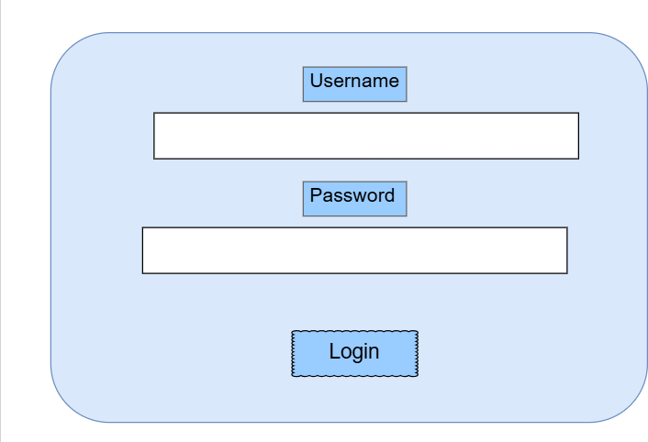
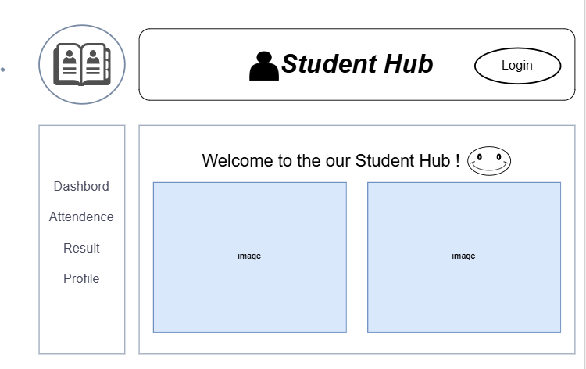

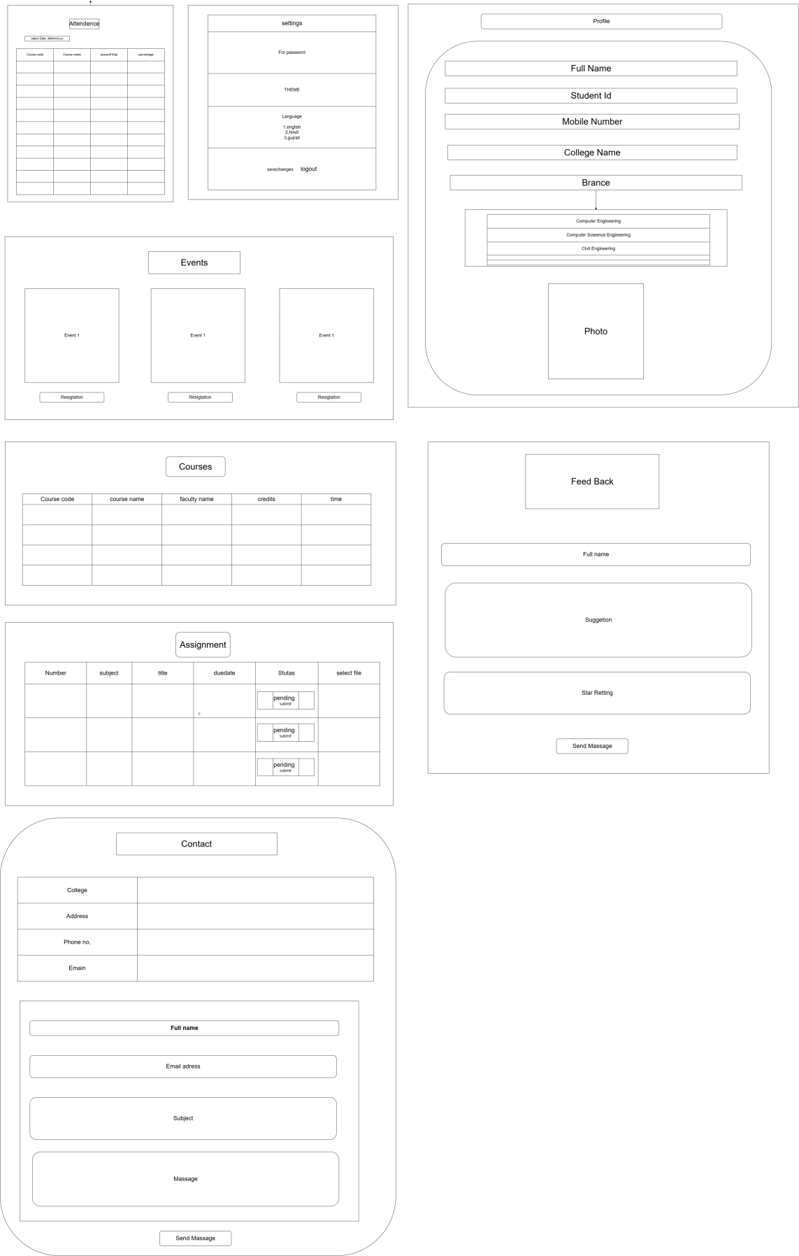

GitHub Repository Link:
https://github.com/AD-9218/Student-Hub

Challenges Faced:
I faced challenges in deciding the page layout, placing elements correctly, and making the design simple.

Learning Outcomes:
I learned how to create a wireframe, plan a webpage layout, and organize website elements in a simple way.

Faculty Remarks: (Keep this blank for faculty)

